WEBSITE

A. HOME
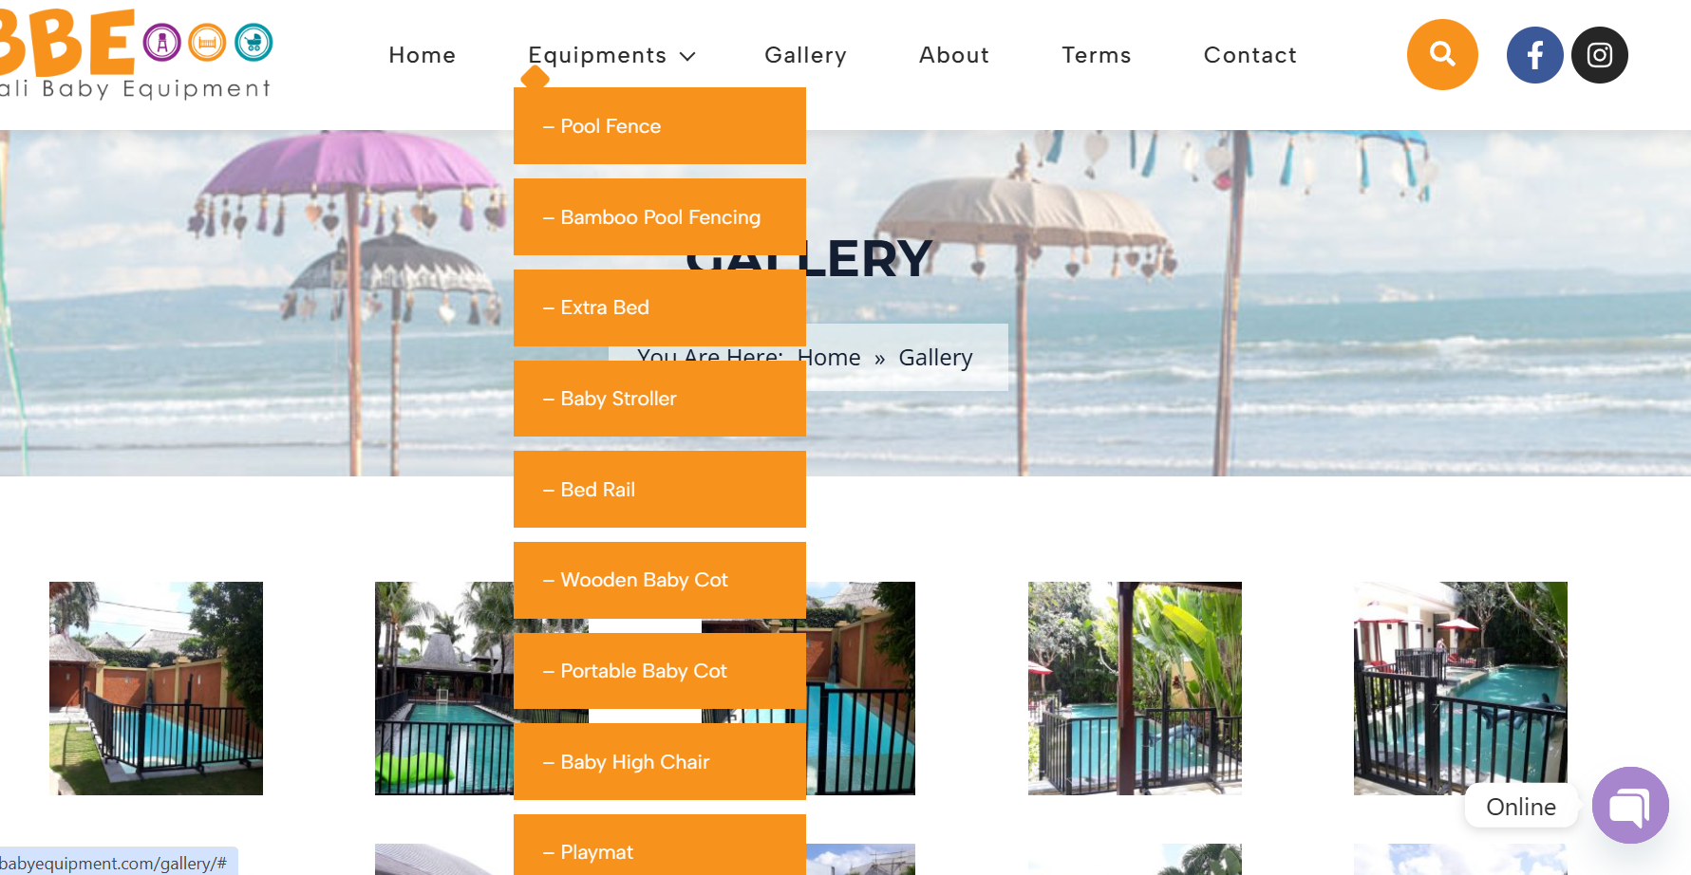
- gabisa scroll hanya stuck content sampai playmat

- Tidak accept paypal, mastercard dan visa
- Bisa transfer via WISE, BCA, OCBC NISP, Cash
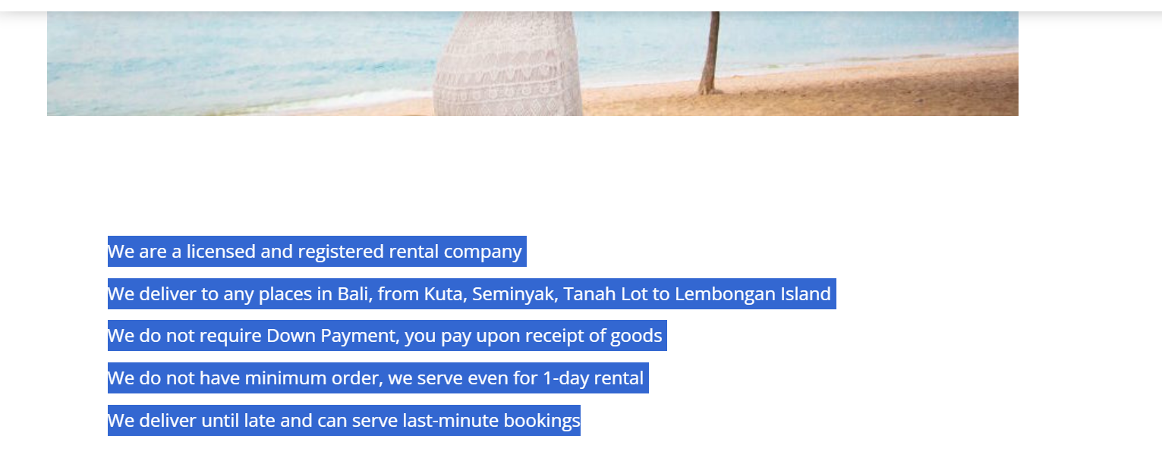
- ganti jadi ini
Licensed and registered rental company.
Mainland Bali delivery, from Kuta to Karangasem and Buleleng.
No down payment required.Pay on delivery.
No minimum order for 1-day rentals (Low Season ONLY).
Late-night delivery and last-minute bookings available.
Available for late inquiries; we respond as soon as we are awake.
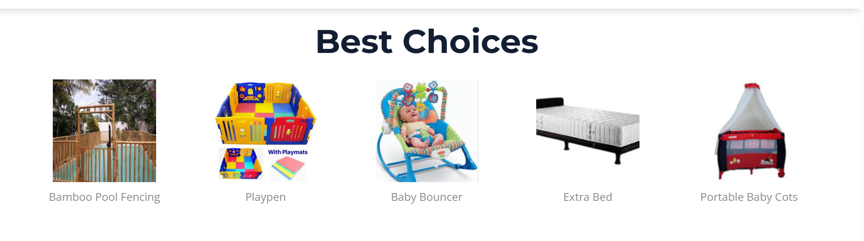
- Ganti gambarnya https://drive.google.com/drive/folders/1L9ZqP2ostH-RJUvRy9UhAVPo0t8qo5qp?usp=drive_link
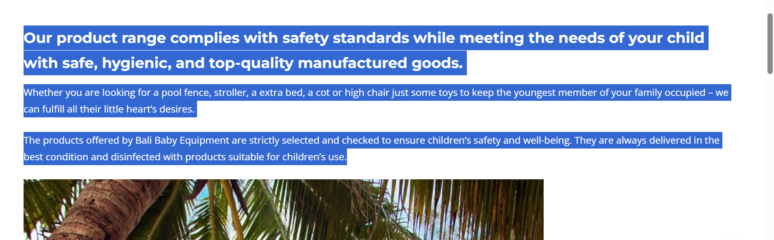
- ganti
Our products meet the highest safety standards to ensure your child’s well-being. From pool fences and toys to extra beds, cots, and high chairs, we provide everything you need to keep your family comfortable and entertained.
Our Quality Promise:
- Strict Selection: Every item is carefully chosen and safety-checked.
- Deep Cleaned: All equipment is disinfected with child-safe products before every delivery.
- Top Condition: We only deliver high-quality, well-maintained goods.
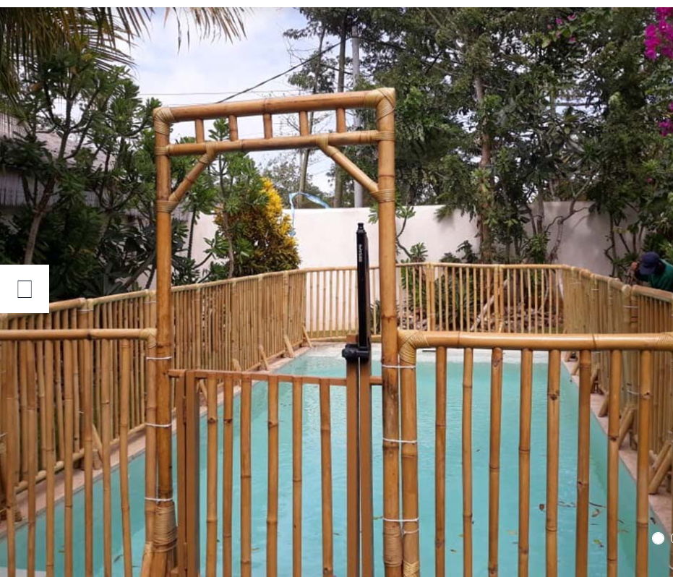
- ganti karena sudah tidak pakai pintu bamboo
https://drive.google.com/drive/folders/1L9ZqP2ostH-RJUvRy9UhAVPo0t8qo5qp?usp=drive_link
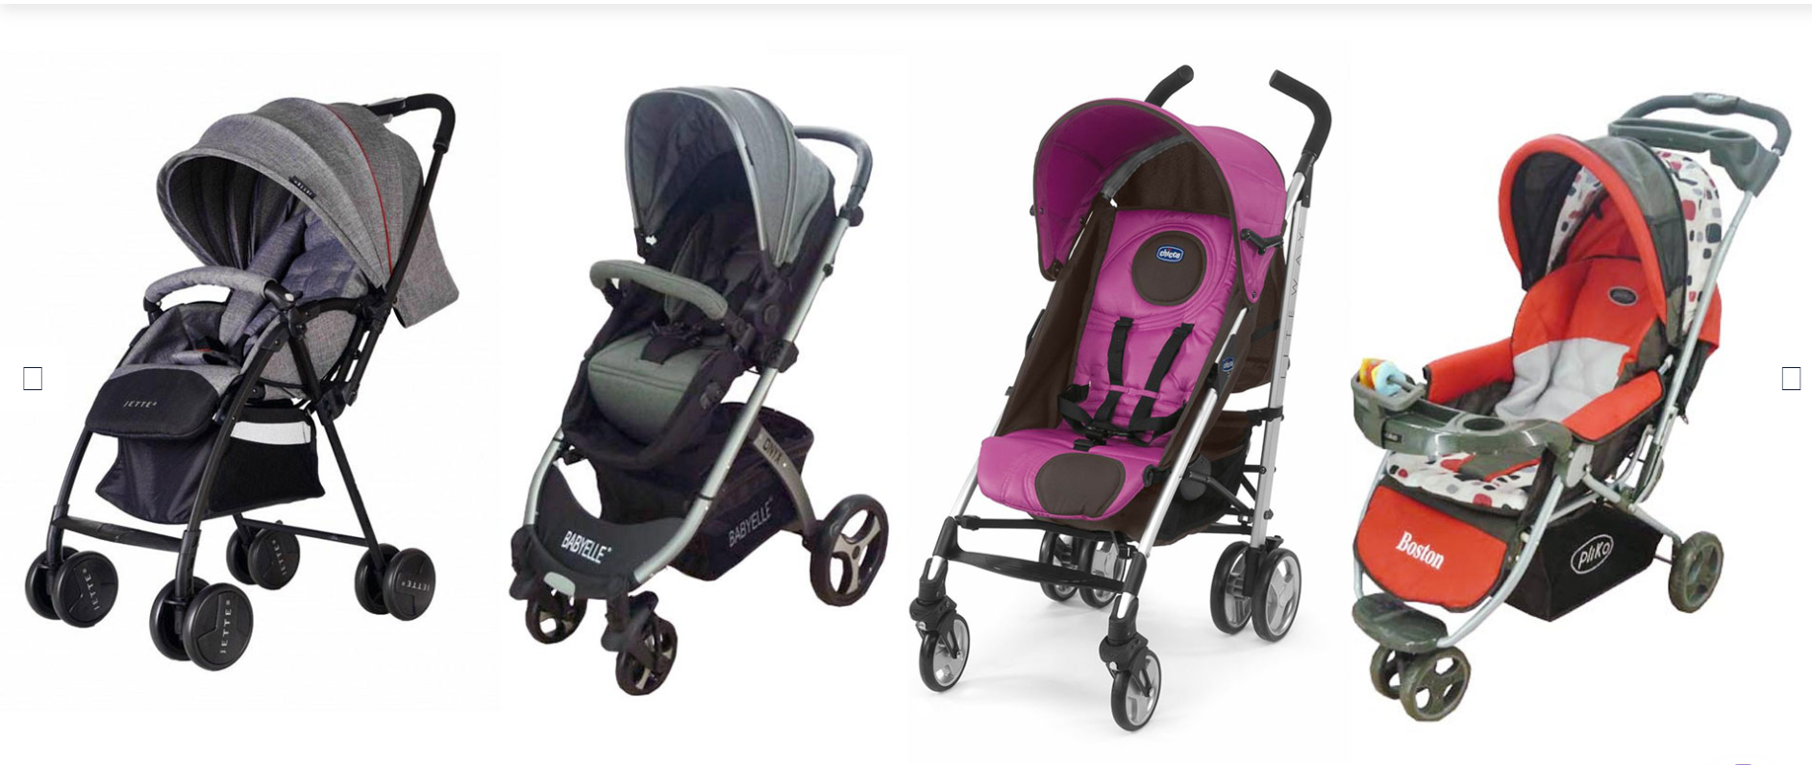
- Remove stroller sudah tidak menyewakan stroller
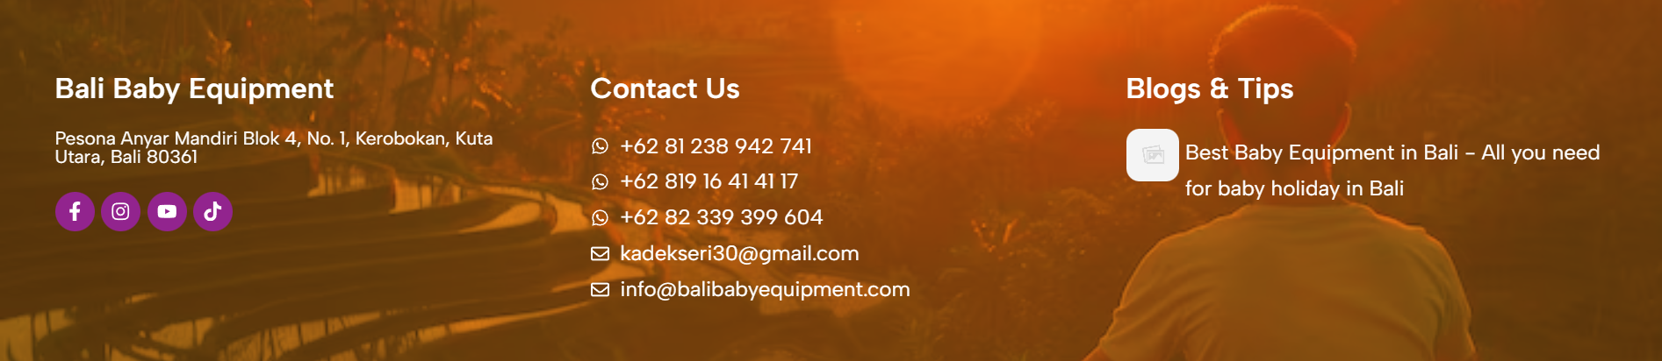
Blog and tips GANTI article jadi ini
The Ultimate 2026 Guide to Traveling in Bali with Kids: Visas, Villa Safety, and Local Tips
Are you planning a family getaway to the "Island of the Gods"? Bali is more family-friendly than ever in 2026, but new travel regulations and safety standards mean you need to be prepared. From the latest immigration rules to finding a scam-free villa, here is everything parents need to know.
1. New Bali Entry Requirements for 2026
Before you pack the diapers, make sure your paperwork is in order. Indonesia has streamlined its entry process, but there are a few mandatory steps:
- The "All Indonesia" App: You must now complete a unified digital entry form (including health and customs declarations) within 72 hours of arrival.
- Visa on Arrival (e-VOA): Most tourists now apply for their 30-day visa online via the official government portal. It costs IDR 500,000 and can be extended once.
- Bali Tourist Levy: Don't forget the mandatory IDR 150,000 tourism tax per person. You can pay this easily via the Love Bali website to avoid queues at the airport.
- Proof of Funds: Starting in 2026, immigration may ask for proof of sufficient funds for your stay. Have a digital bank statement ready just in case!
2. How to Safely Book a Villa (and Avoid Scams)
Bali villa scams are unfortunately rising. Fake listings on social media often use stolen photos of real luxury properties.
- The Red Flags: If the price is "too good to be true" or they demand a bank transfer to a personal name, be careful.
- Verify the Business: Always check if the company is registered. Check via https://bvrma.org/verification-page/
- Our Connection: Feeling overwhelmed? We have a trusted network of villa partners. If you are struggling to find safe, family-friendly accommodation, contact us via WhatsApp. We can connect you directly with verified villa managers to ensure your booking is 100% secure.
3. Bali Etiquette: The Family Do’s and Don'ts
Balinese culture is incredibly welcoming to children, but there are a few local customs to respect:
- DO dress modestly (cover shoulders and knees) when visiting temples.
- DON’T touch the heads of Balinese people—including children. The head is considered the most sacred part of the body.
- DO use your right hand when giving or receiving items (money, food).
- DON’T step on the Canang Sari (small flower offerings on the ground). If you accidentally step on one, a simple "Sorry" is fine.
- DO bring your own reusable water bottle. Most villas now have gallon dispensers to reduce plastic waste.
4. The Secret to a Stress-Free Holiday: Pack Less, Rent More
Why pay airline surcharges and risk damaging your expensive stroller? Bali Baby Equipment (BBE) provides a "home away from home" setup.
- Pool Safety: Most Bali villas have open pools. We provide Professional Pool Fence Installation to keep your toddlers safe while you relax.
- Hassle-Free Logistics: We coordinate directly with your Villa Manager or agent to have your Wooden Cot, High Chair, and Toys installed before your flight lands.

Quick Tips for Parents:
- Water: Never drink tap water; use it only for showering. Use bottled water for formula and brushing teeth.
- Transport: Book a car with a fitted car seat. We provide private tours and transfers with international safety seats.
Ready to book your equipment or need a villa recommendation? Chat with our friendly team on WhatsApp at +62 812-3894-2741. Let us handle the heavy lifting while you enjoy the sunset!

B. EQUIPMENT

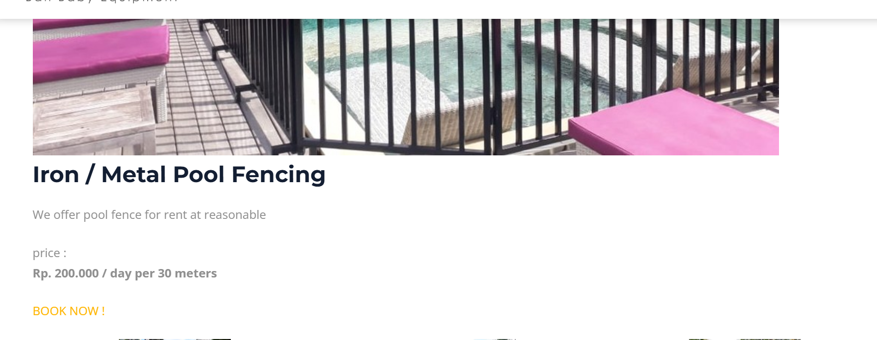
Iron / Bamboo Pool fence
1. Ganti gambar bamboo cek link drive
2. Ganti description
Ensure total peace of mind during your holiday with our professional pool fencing. Designed for maximum safety and easy visibility.
- Height: 1 meter high for standard panels.
- Safety Gate: 1.5 meters high with an automatic locking system.
- Price: IDR 200.000 per night per 30 meters
- Quality: Sturdy, reliable, and meeting child-safety standards.
For more information or to ask about seasonal discounts, contact us via Email or get a faster response via WhatsApp.
Book Now

Extra bed
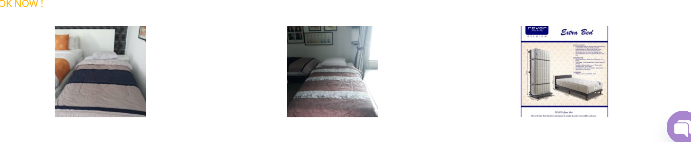

- Ganti gambarnya cek link
- Jangan pakai description ini -> Our Extrabed has two types, folding bed and proper bed. The size of our proper bed is 100 x 200cm (single-size), it includes fitted sheet, pillow, pillow case, and blanket.
Price
Rp. 175.000/ night
Rp. 150.000 more than 3 days
Rp. 130.000 more than 10 days
Ubah menjadi ->
We offer high-quality extra beds (100cm x 200cm) to ensure a comfortable night's sleep for your additional guests.
Complete Set Includes:
- Comfortable mattress (100x200)
- Fresh bed sheets & pillowcases
- Pillow
- Cozy bed cover

Rental Pricing
- IDR 175.000 per night
- IDR 150.000 per night (for rentals over 3 nights)
- IDR 130.000 per night (for rentals over 10 nights)
Prices exclude delivery fees. We offer additional discounts for bulk rentals—contact us for a quote!
NOTE: Warna font ganti jangan grey pucat

Wooden cot
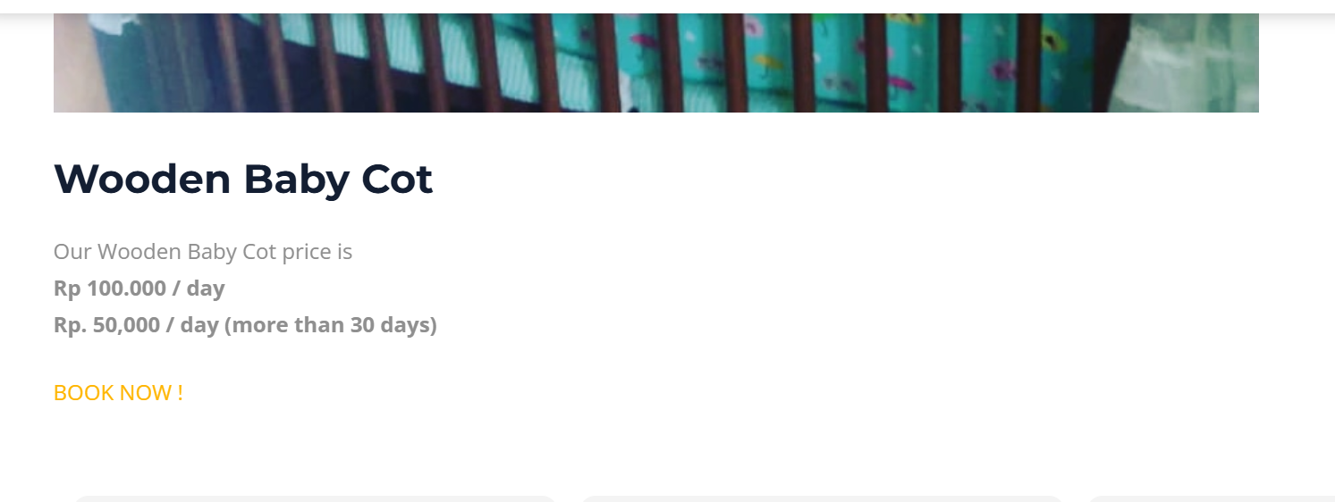
- Ganti foto
- Ganti desc
Our classic wooden cots provide a safe, sturdy, and comfortable sleep environment for your little one. Designed for children up to 2 years old.
- Dimensions: 1.15 × 1.35 × 1.0 m (H × L × W)
- Included: Mattress, fitted sheet, protective bumper, pillow, and mosquito net.
- Note: Please bring your own baby blanket, as it is not included for hygiene reasons.
Rate: IDR 100.000 / night
Discounts available for long-term rentals.

Portable Baby cot
Ganti desc dari
Price :
Rp 60.000 / day
Rp 50.000 more than 3 days
Rp 40.000 more than 10 days

Inclusions : Mattress, Pillow, Pillow Case, Mosquito Net
Menjadi ->

Price :
IDR 60.000 per night
IDR 50.000 per night for more than 3 nights of rental
IDR 40.000 per night for more than 10 nights of rental

Inclusions : Mattress, Pillow, Pillow Case, Mosquito Nett
Exclusion : Baby Blanket

Baby chair

Ganti ini
Our baby high chair price is
Rp 25.000 / day
Rp 20.000 more than 3 days
Rp 15.000 more than 10 days
Menjadi ini
Our baby high chair price is
IDR 25.000 / night
IDR 20.000/night for more than 3 nights of rental
IDR 15.000/night for more than 10 nights of rental

Playpen
Gambar ada di drive
Description
Playpen with mattress included is
IDR 50.000 / night
IDR 40.000/ night for more than 10 nights of rental

Bottle Steriliser
Gambar ada di drive
Price is
IDR 40.000/ night
IDR 30.000/ night more than 10 nights of rental

Airport Transfer (with Car Seat)
Start your holiday without the stress of navigating airport crowds or worrying about safety. Our private transfer service ensures your family is picked up in a clean, smoke-free vehicle with a professionally fitted car seat already installed.
Pricing (One-Way Trip including 1 Car Seat):
- Kuta / Legian: IDR 300,000
- Seminyak / Sanur / Nusa Dua: IDR 350,000
- Canggu: IDR 400,000
- Uluwatu: IDR 450,000
- Ubud (Center): IDR 500,000
What’s Included:
- Private AC vehicle (Suzuki APV or similar).
- English-speaking driver who will meet you with a name sign.
- Airport parking fees and petrol.

Private Day Tours
Explore the beauty of Bali at your own pace. Whether you want to see the Ubud Monkey Forest, visit the Tanah Lot sunset, or explore the waterfalls of North Bali, we provide the safest way for families to travel.
Pricing: *Contact us via WhatsApp for a Custom Quote.
- Rates depend on your itinerary, duration, and destination.
Why Book a Tour with Us?
- 100% Flexible: You choose the stops; we handle the driving. No fixed schedules!
- Safety First: Every tour vehicle comes with internationally standard car seats fitted correctly for your child's age.
- Family-Friendly Drivers: Our drivers are patient, non-smokers, and happy to stop for diaper changes or feeding breaks.
- Expert Local Knowledge: We can recommend the best family-friendly restaurants and "scroller-friendly" paths at major attractions.

C. Terms & Delivery
Delivery & Pickup Rates (Includes Professional Installation)
All delivery fees listed below cover the full return trip (delivery, setup, and pickup).
Seminyak, Canggu, Kuta, & Legian
- FREE for rentals of 6 nights or more.
- IDR 50.000 for small items (Cots, High Chairs, etc.) under 6 nights.
- IDR 100.000 for large items (Pool Fences, Extra Beds) under 6 nights.
Ubud, Jimbaran, Bingin, Nusa Dua & Uluwatu
- FREE for rentals of 10 nights or more.
- IDR 150.000 – 300.000 for rentals under 10 nights (based on item and exact location).
Other Areas
- Regional (Klungkung, Karangasem, Gianyar, Tabanan): IDR 400.000.

Terms & Conditions
- Hassle-Free Setup: Professional installation is included in your delivery fee.
- Minimum Stay: 2 nights minimum rental required.
- Payment: Pay after installation. Once payment is processed, it is non-refundable.
- Cancellations: Fees apply for last-minute cancellations.
- Equipment Care: Lost or damaged items will be charged the full replacement price.
- Relocation: Moving items to a different property must be reported to us first.

D. FAQ (Q&A) page

Lebih baik page ABOUT diganti menjadi Q&A page
Frequently Asked Questions
How do I pay for my rental?
We do not require a down payment. You simply pay in cash or via transfer upon delivery and installation. Once payment is made, it is non-refundable.
Are delivery, pickup, and installation included?
Yes! Our delivery fee covers the full return trip (delivery and pickup) and includes professional installation by our team. For a full list of delivery rates by area, please visit our [Terms & Conditions] page.
How can I contact you for a fast response?
The fastest way to reach us is via WhatsApp. You can message us at:
- +62 812-3894-2741
- +62 823-3939-9604
What happens if I need to cancel?
Please let us know as soon as possible. Last-minute cancellations will incur a cancellation fee.
How do you calculate the rental charge?
We charge per night, similar to a hotel.
- Example: If you rent from January 2nd to January 6th, that is calculated as 4 nights.
Do you provide blankets with the cots?
To maintain the highest hygiene standards, we provide the mattress, sheet, bumper, and mosquito net, but we ask that you bring your own baby blanket.
Can I move the equipment to my next villa?
If you are moving locations during your stay, please inform us. We need to track our equipment to ensure it is handled safely.
How do I arrange delivery and pickup?
To make your arrival as smooth as possible, please provide us with the contact details of your Villa Manager or the person in charge of your accommodation. We will coordinate directly with them to arrange the perfect delivery and pickup times.
Do you sell bamboo or iron pool fences?
Yes! We offer both new and second-hand bamboo and iron fences for sale. Please contact us via WhatsApp to receive a custom quotation and check our current stock.
Do I need to pay a security deposit?
- Baby Gear, Pool Fences, & Extra Beds: No security deposit is required.
- Toy Rentals: We require a small security deposit of IDR 100,000, which is fully refundable upon the return of the items in good condition.
Can I rent for just one day?
During the low season, we are happy to provide 1-day rentals with no minimum order. During peak seasons, a minimum rental period may apply.

E. Partner ( kalau bisa)
Villa & Travel Partner Program
Elevate your guest experience by partnering with Bali’s trusted baby equipment provider. We offer seamless integration for luxury villas and travel agencies.
Our Partnership Standards
- Tailored Logistics: We coordinate directly with your on-site management for streamlined delivery and pickup.
- Priority Fulfillment: Access to our inventory even during peak seasons for our registered partners.
Registration
Access to our partner portal is restricted to licensed travel and hospitality professionals. To request more details, please verify your business via WhatsApp or Email.

